Please fill in the form and send to: Birmingham Bank Ltd, Lewis Building, Ground floor, Spaces, 35 Bull Street, Birmingham, B4 6AF
Direct Debit Mandate

- Name and full postal address of your bank or building society
Service user number
5 | 0 | 9 | 5 | 3 | 6

Reference (optional)

________________________________________
To the Manager
Bank/building society
Address
Postcode

- Your details
Name of account holder ________________________________________
Branch Sort Code

Bank/Building society account number

- Instruction to your Bank or Building Society
Please pay Birmingham Bank Ltd Direct Debits from the account detailed in this Instruction subject to the safeguards assured by the Direct Debit Guarantee. I understand that this Instruction may remain with Birmingham Bank Ltd and, if so, details will be passed electronically to my Bank/Building Society.

Signature:

_________________________________________
Date:

_______________________________________

✂ - - - - - - - - - - - - - - - - - - - - - - - - - - - - - - - - - - - - - - - - - - - - - - - - - - - - - - - - - - - - - - - - - - - - - - - - - - - - - - - - - - - - - - - - - - - - - - - - - - - - - - - - - - - - - - - - -
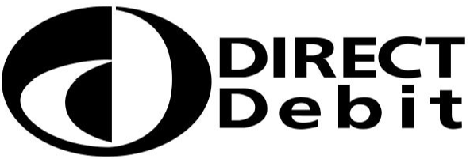
Banks and building societies may not accept Direct Debit instructions for some types of account.
This guarantee should be detached and retained by the payer.
The Direct Debit Guarantee

- This Guarantee is offered by all banks and building societies that accept instructions to pay Direct Debits.
- If there are any changes to the amount, date or frequency of your Direct Debit Birmingham Bank Ltd will notify you ten working days in advance of your account being debited or as otherwise agreed. If you request Birmingham Bank Ltd to collect a payment, confirmation of the amount and date will be given to you at the time of the request.
- If an error is made in the payment of your Direct Debit, by Birmingham Bank Ltd or your bank or building society, you are entitled to a full and immediate refund of the amount paid from your bank or building society
- If you receive a refund you are not entitled to, you must pay it back when Birmingham Bank Ltd asks you to
- You can cancel a Direct Debit at any time by simply contacting your bank or building society. Written confirmation may be required. Please also notify us.

